## AP Options

AP Options are used for connecting to an Access Point. Basic parameters are SSID and Passphrase. If SSID and Passphrase are entered, then these parameters are used while loading the ELF using PROG Ram/ PROG Flash.

**Note**: Tool will internally generate the network profile as JSON file, stores it in the Talaria TWO file system and passes this JSON file path as a boot argument, while loading the application.

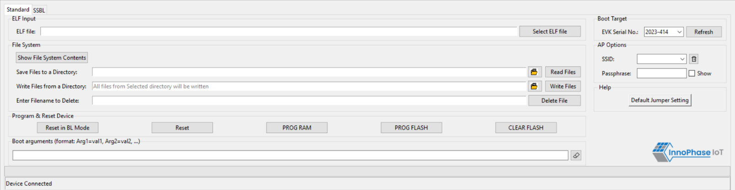

Figure 23: AP Options